***Task 1*** *: We’re new to Lightning, and starting to make the most of component’s flexibility to*

*show our customer service agents the most important information as, and when, they*

*need it. This might be displaying the customer’s other open issues as they’re talking to*

*them. For this task, we’d like you to display the customer’s product information to the*

*agent whilst they’re interacting. This Lightning component (or Lightning web*

*component , if you prefer) should:*

*a. Be visible to the agent on the Case page layout*

*b. Use two custom fields (‘Product__c’ and ‘Home_Country__c’) from the related*

*Contact record to determine the customer’s product and legal country*

*c. Use the values in these fields to display the matching product information*

*The product information to be displayed can be found in the tables given at the end.*

*Each column in the tables below corresponds to a value in the ‘Home_Country__c’ field,*

*and each row relates to a specific ‘Product__c’.*

*Please note that this is subject to change and new factors, such as length of contract or*

*special packages, could influence any costs and fees. Modifying the existing product*

*information, or adding entirely new products, should be as simple as possible.*

**Solution:**

* First, I have created a new developer edition org with country as Germany.
* I have created an N26 lightning app for this case study as shown below:

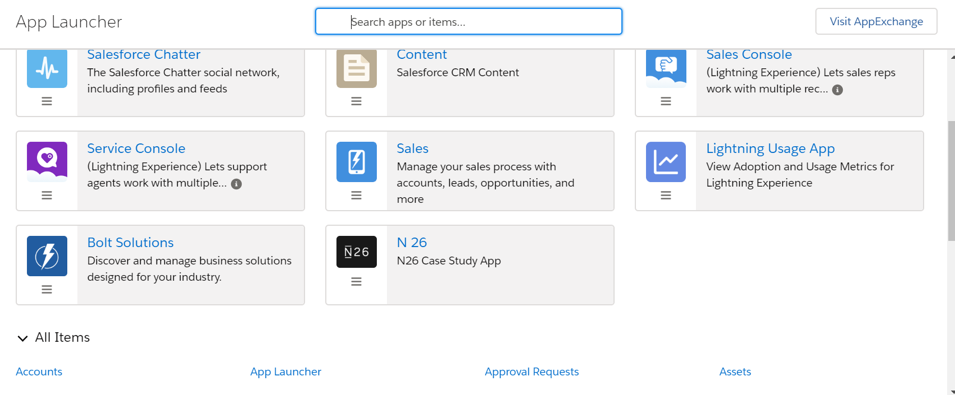

* NOTE : - You need to activate the multiple currencies under Company profile. After you will get an option of “**manage currencies” under company profile**. As shown below:

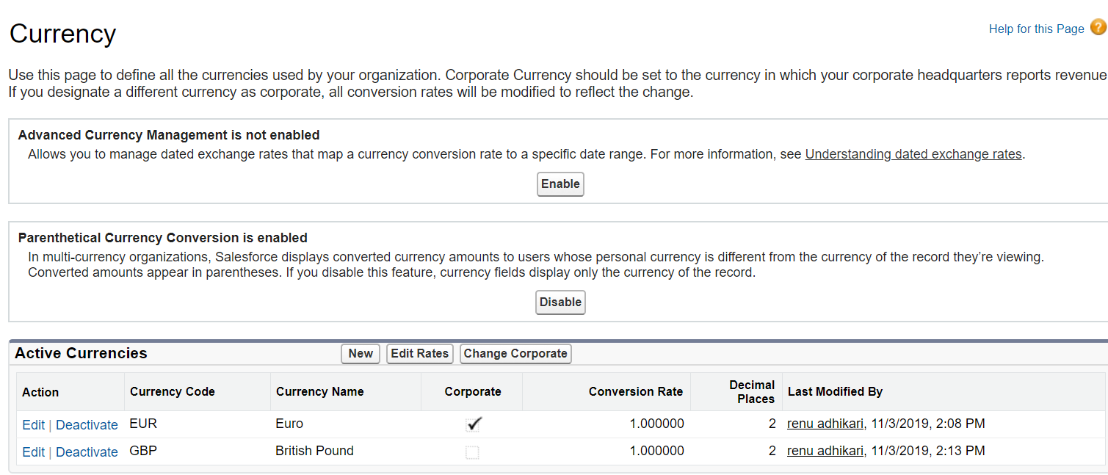

* Wherein, I have added the British Pound.
* Company information looks as shown below :-

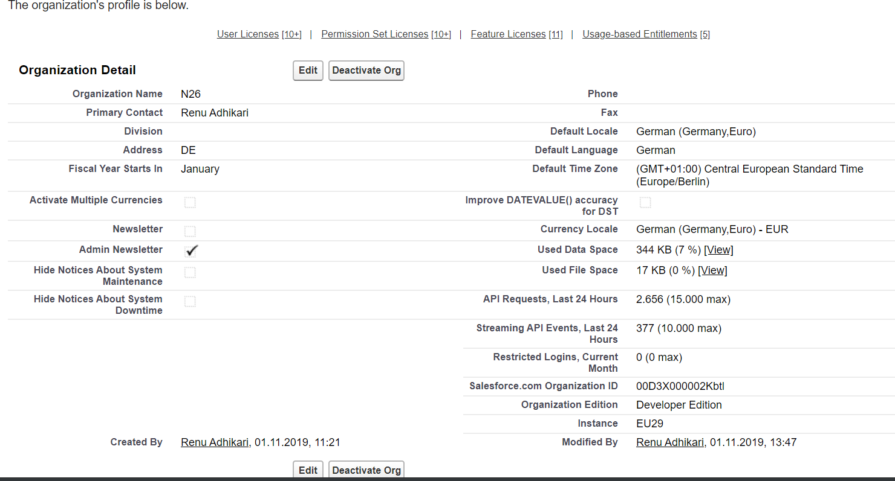

* When you will click on the N 26 app, you will be navigated to the below screen with tabs : Home, Account, Contact, Cases, Products and Product Inventories.

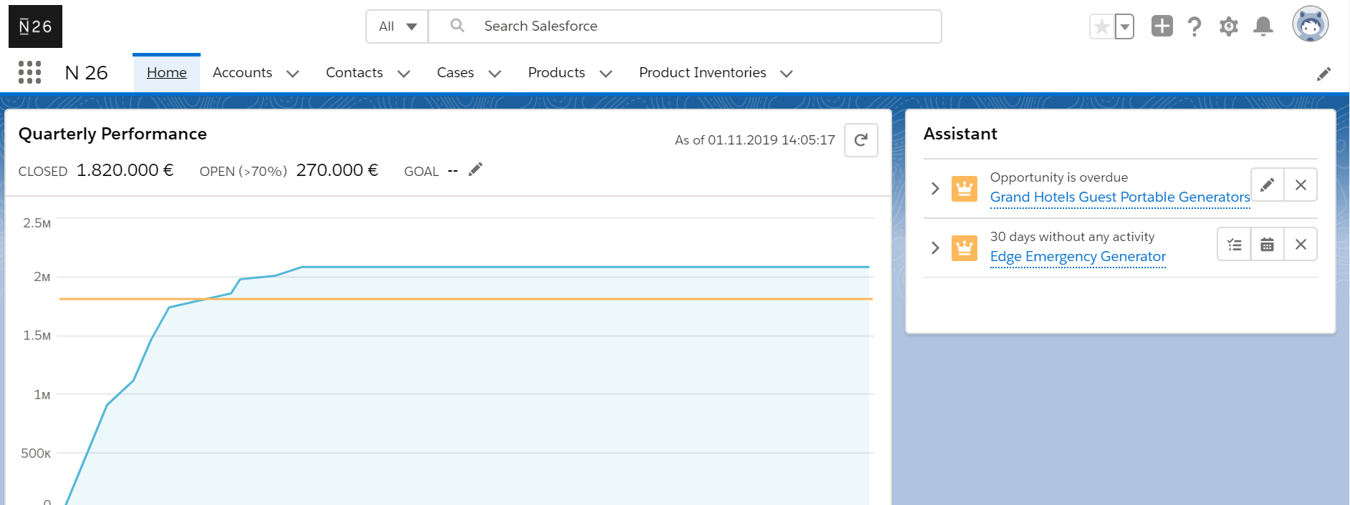

* Below you will notice that for “John Bond” contact, we have three fields namely – Home Country, Language and Product. Here, I have selected Home Country as IT and Product as Metal.

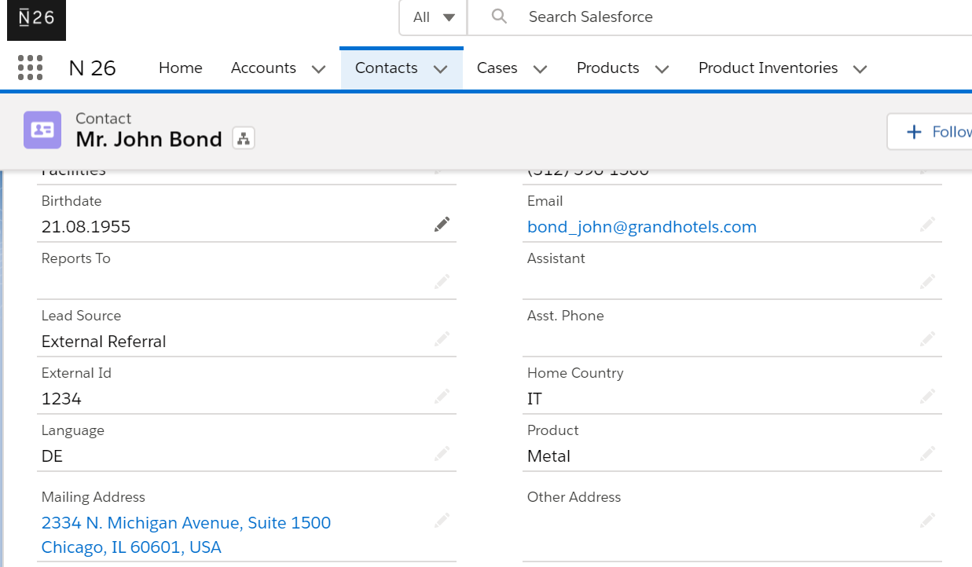

* Contact John has 2 cases as shown below:

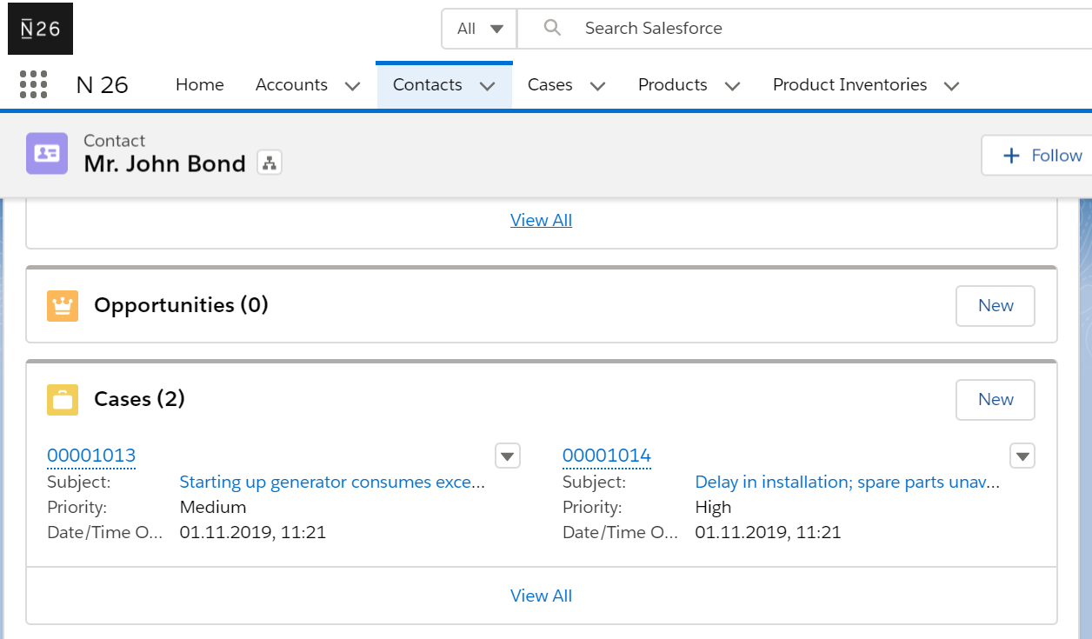

* Here, click on any case you can see the products details as shown below:
* For this, I have created the lightning component - “ProductInformation” which is calling aura enabled apex class – “ProductsController”

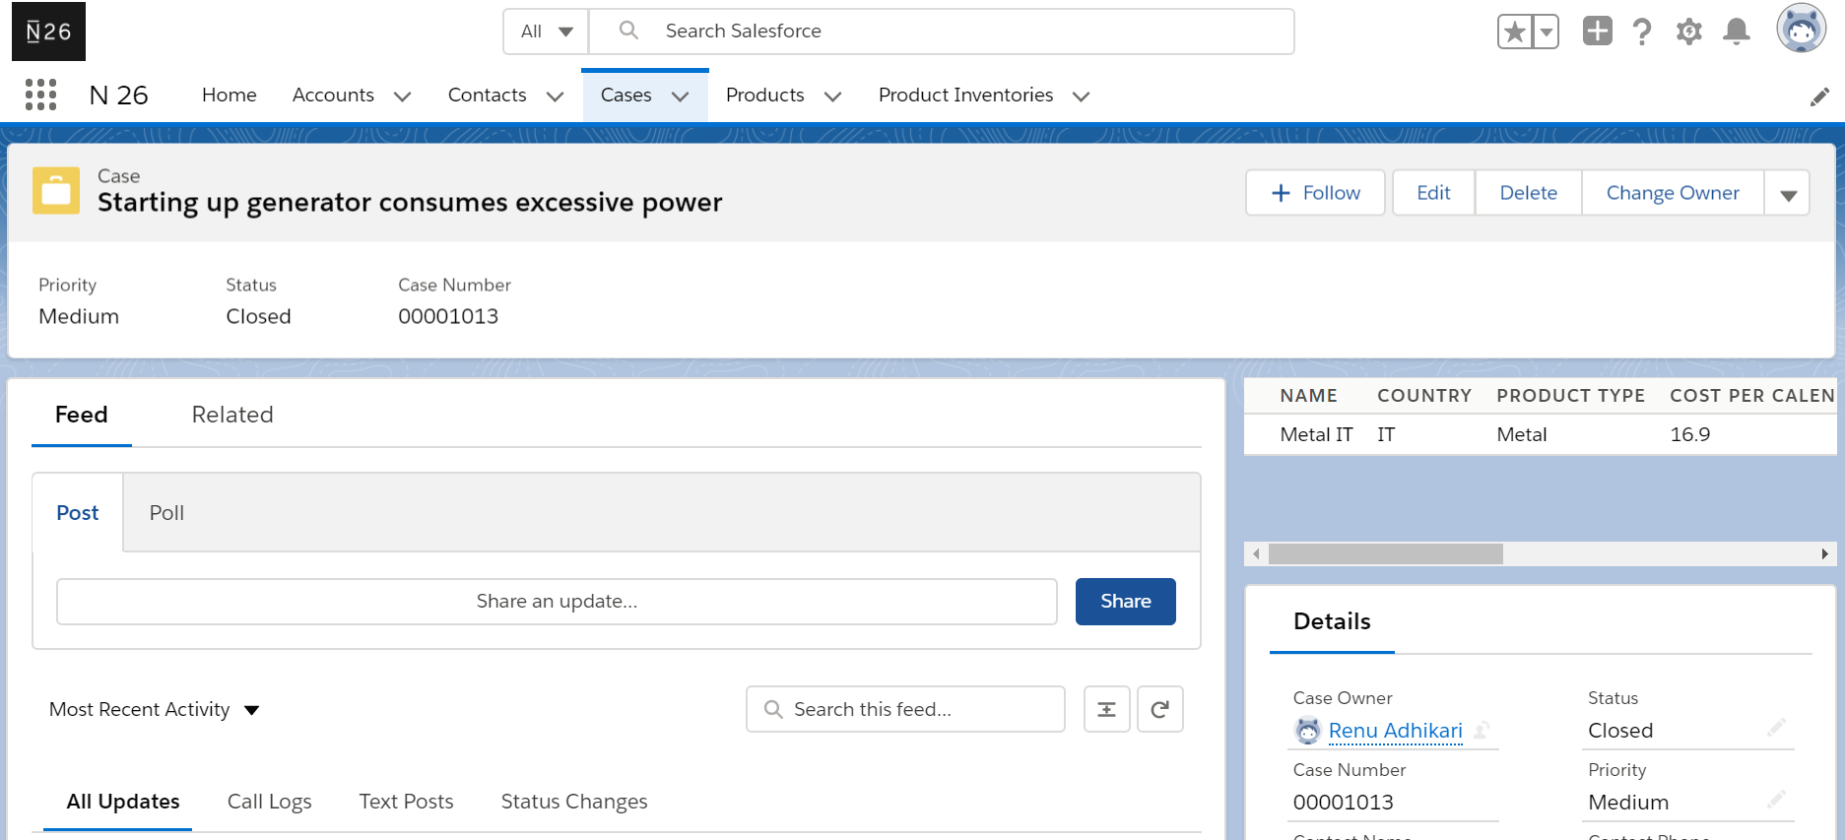

* Similarly, for Product “All” you will get the complete list of products. For this, In contact, change the value of Product from “Metal” to “All”:

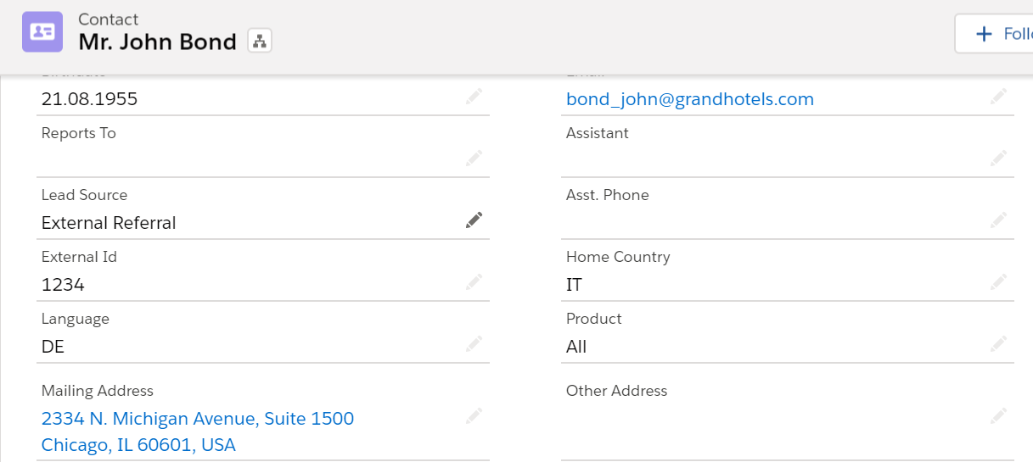

* All Products on cases will be shown as below:

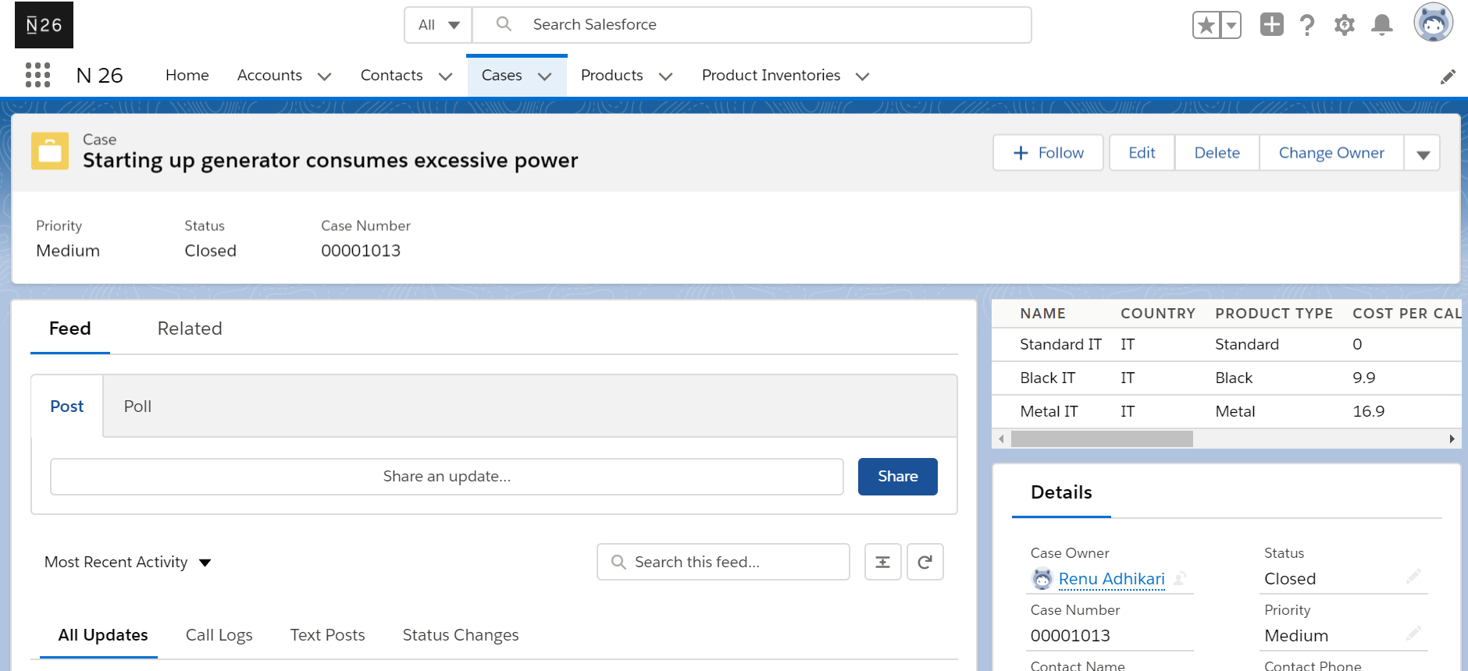

***Task 2*** *:* *N26 also uses an external system, where the customer data is shown from Salesforce.*

*The team would need a mechanism to connect to Salesforce and get the relevant*

*information.*

*External system passes a unique identifier (UUID) that is mapped to every contact*

*record in Salesforce.*

*Design an API that would be able to return the data for a contact based on the table*

*below.*

**Solution**:

* For this task, I am making the REST API call from workbench(<https://workbench.developerforce.com/restExplorer.php>) and passing the UUID from workbench to get the relevant information from salesforce.
* I have created a field on contact called “External ID” of type Text which is Unique Case Insensitive and created the Apex class - CustomerDetails
* Please click on above link and enter the org credentials to login. Then enter below URI - /services/apexrest/N26/customerDetails?UUID=09876 in REST Explorer.
* For contact “Ms. Rose Gonzalez”, I have used the External ID = 09876 as shown in below screenshot in salesforce:

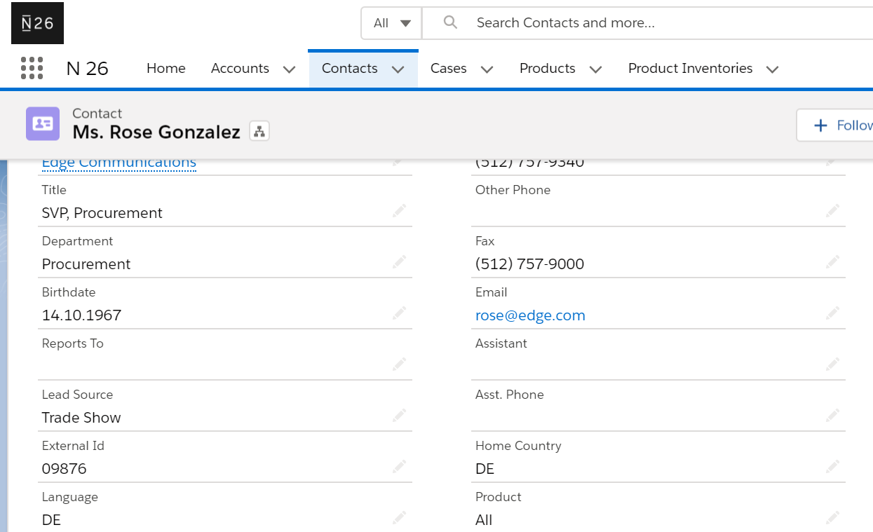

* From external system, I am entering the “External ID” from Workbench REST Explorer to get the relevant information from salesforce.

